**Practical – 7**

**Aim: -** Managing user account in windows and Linux.

**Managing User account in Windows 10**

1. In the setting window click accounts and then click family and other users.
2. Click the account you want to modify to display the options then click change account type click to view a larger image any account can be an administrator account.

Creating a new user account using windows 10 setting application you may also create a Microsoft account to be able to transfer accounts and files between computers

1. Click on the start menu in the taskbar
2. Select the setting icon indicated by a gear.

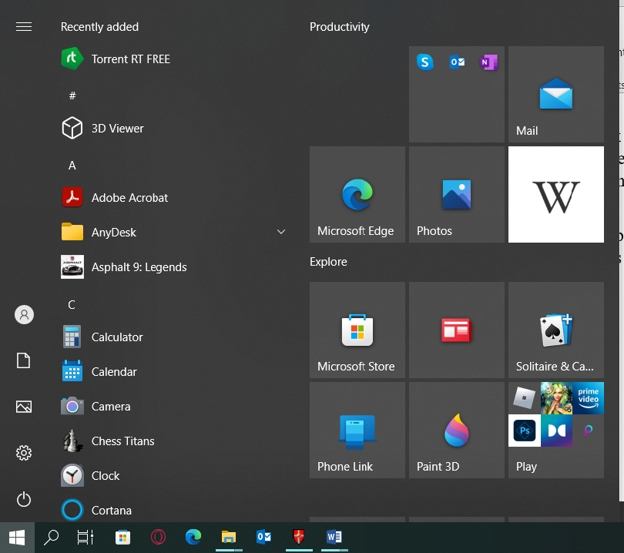

1. 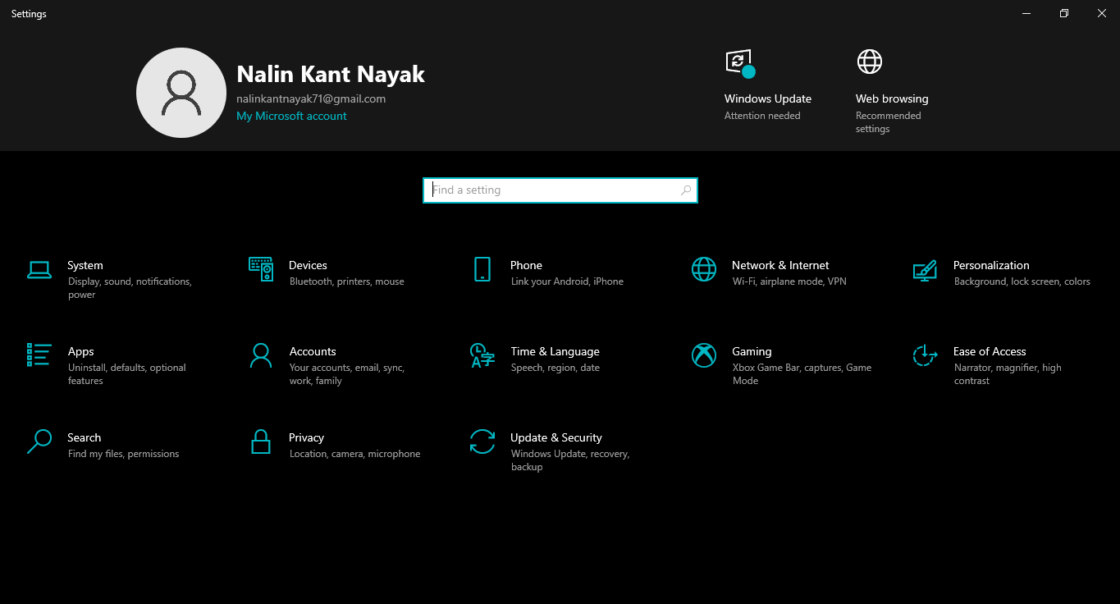Click on the accounts.
2. Switch to the family and other users categories using the panel on the left side of the screen you should see a list of all the current users on the computer.
3. 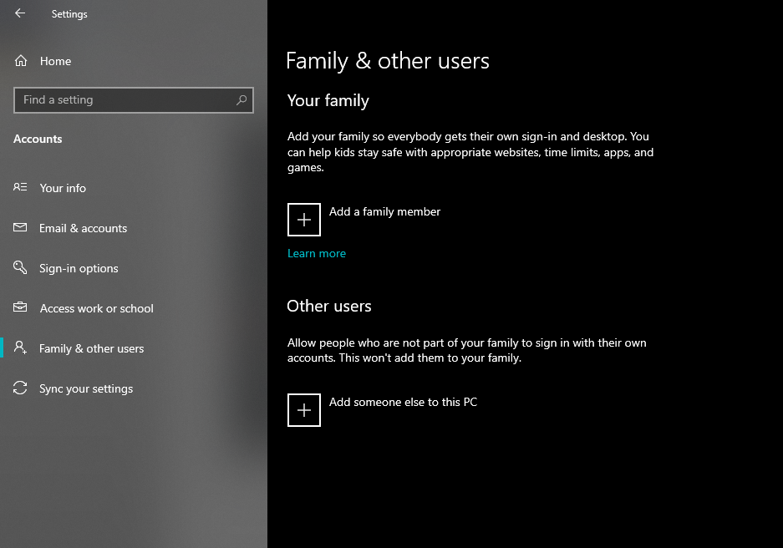Click on the *Add someone else to this PC.*
4. To add a new local user select the *I don’t have this person sign in information option.*

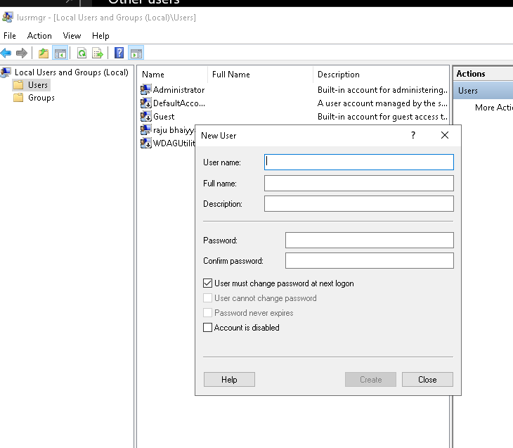

1. Enter the desire user name if needed you can also include a password and a password hint this will give a extra privacy to the user of the account in the future you are always able to change all of this information.
2. Click next to finalize the new account.

**How to make a local user to an administrator account in windows 10**

1. Click on the start menu in the task bar.
2. Select the settings icon indicated by a gear.
3. Click on the accounts
4. Switch to the family and other users categories using the panel on the left side of the screen.
5. Select the account you want to modify by clicking on it once click on the visible change account type button.
6. 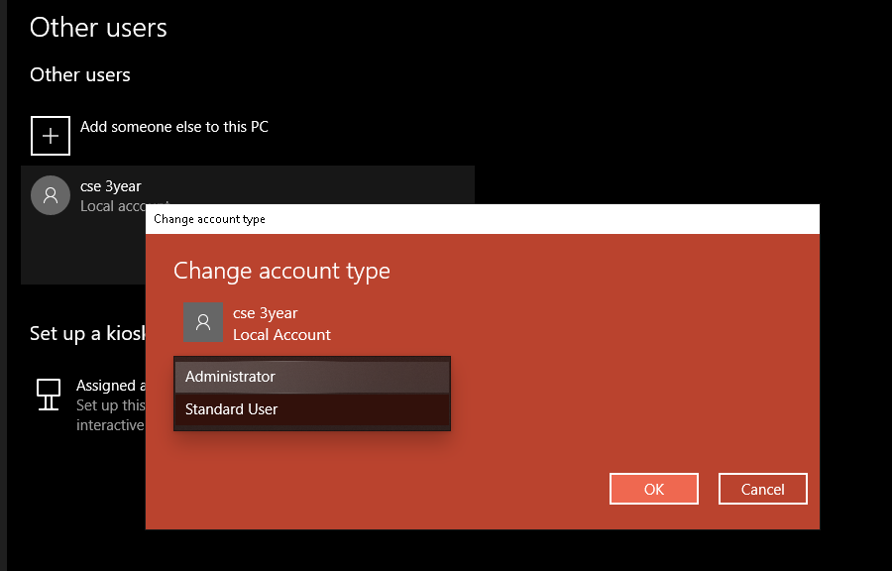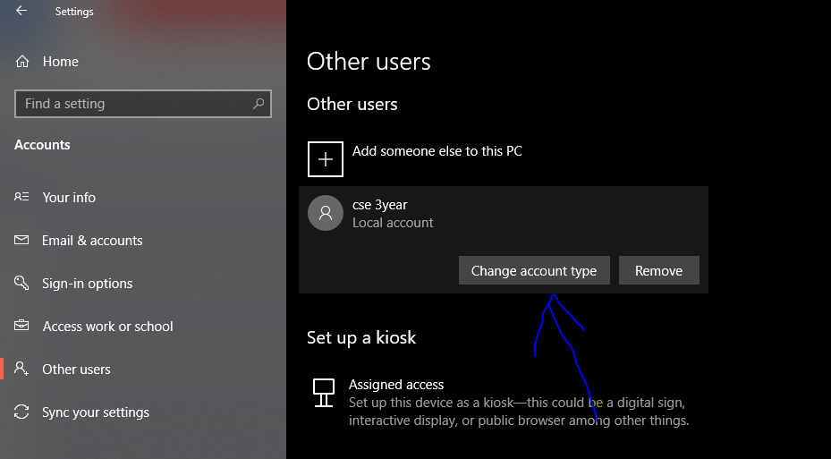 Click on the drop down menu and switch from standard user to administrator.
7. Click the ok button the account now has full access and administrative permissions on the device.

**How to remove a local user in Windows 10.**

1. Click on the start menu in the task bar.
2. Select the settings icon indicated by a gear.
3. Click on the accounts
4. Switch to the family and other users categories using the panel on the left side of the screen.
5. Select the account you want to delete by clicking on it once click on the now visible remove button.
6. 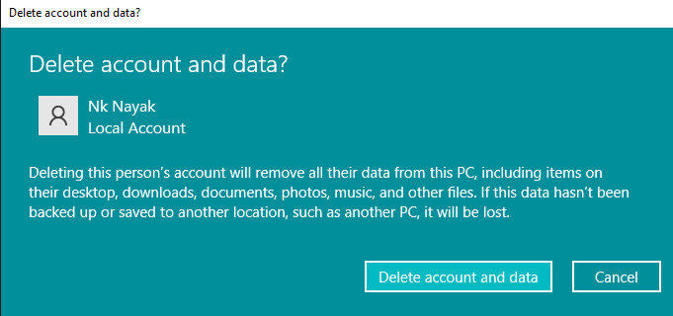Make sure to read the warning before clicking the delete account button wait for windows 10 to process your request and remove the local user.

**User management in Linux**

1. Use the *awk* command with –f option we are accessing a file and printing first column with the help of *awk*.
2. Using id command you can get the id of any user name every user has an id assign to it and the user is identify with the help of this id.
3. Using passwd command through assign a password to a user after using this command we have to enter the new password for the user and then the password get updated to the new password.
4. The command to change the user id for a user

**Syntax: user mod –u new id user name**